1 Patient I want to receive pressure alert System alerts patient when high-pressure regions are detected .
User
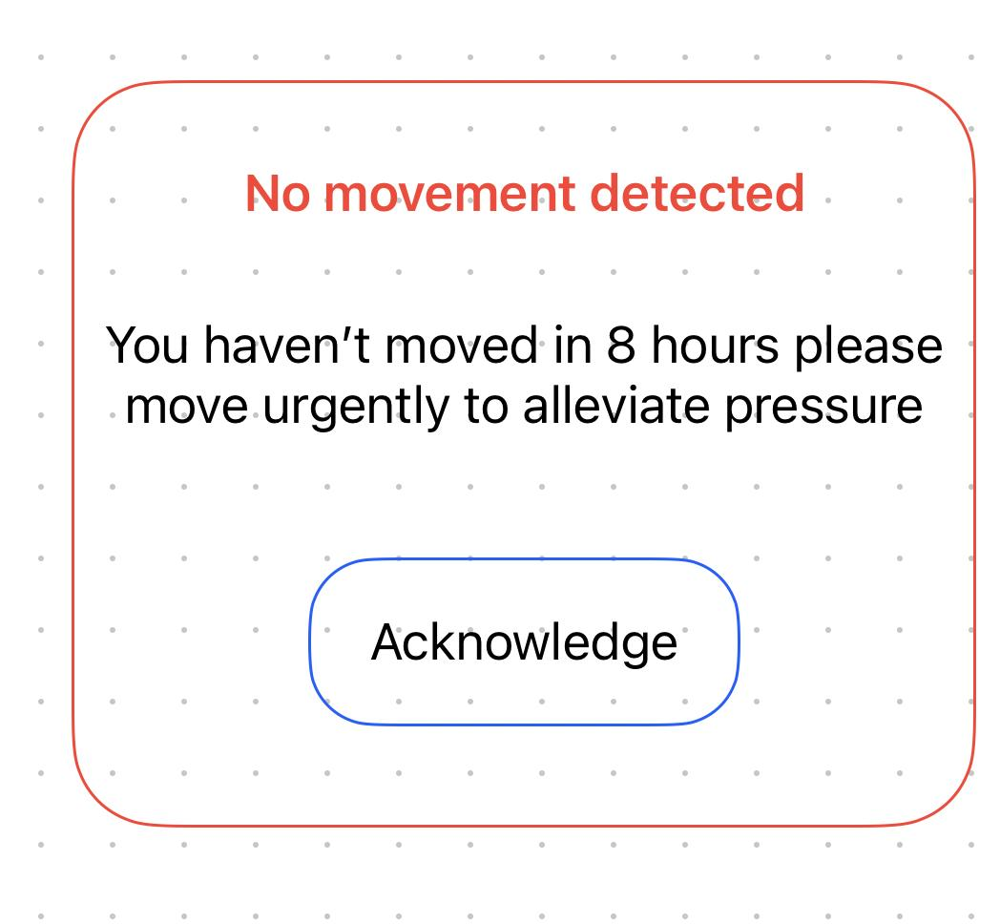

Actors:
Patient, System
Goal:
To notify the patient when a high-pressure region is detected so they can adjust position to reduce risk.
Trigger:
System detects pressure values above the predefined threshold.
Preconditions:
- Patient is registered in the system
- Pressure sensors are active and connected
- Patient’s device (mobile app/dashboard) is online
Postconditions:
- Patient receives pressure alert
- Alert is stored in the system log
Main Flow:
- Sensor sends continuous pressure readings to the backend system.
- System analyses pressure data.
- System detects a value above the high-pressure threshold.
- System generates an alert.
- System sends the alert to the patient's interface (app/dashboard).
- Patient views the alert message.
Alternative Flows:
A1: Patient does not view the alert
→ System sends reminder notification after X minutes.
A2: Pressure returns to normal before alert is displayed
→ System logs event but no alert is shown.
Exception Flows:
E1: Sensor offline → System displays “Sensor not detected” warning.
E2: Network failure → System queues alert and sends later.

2 Clinician: I want to receive no-movement alert Notifies clinician if patient hasn’t moved for 8+ hours
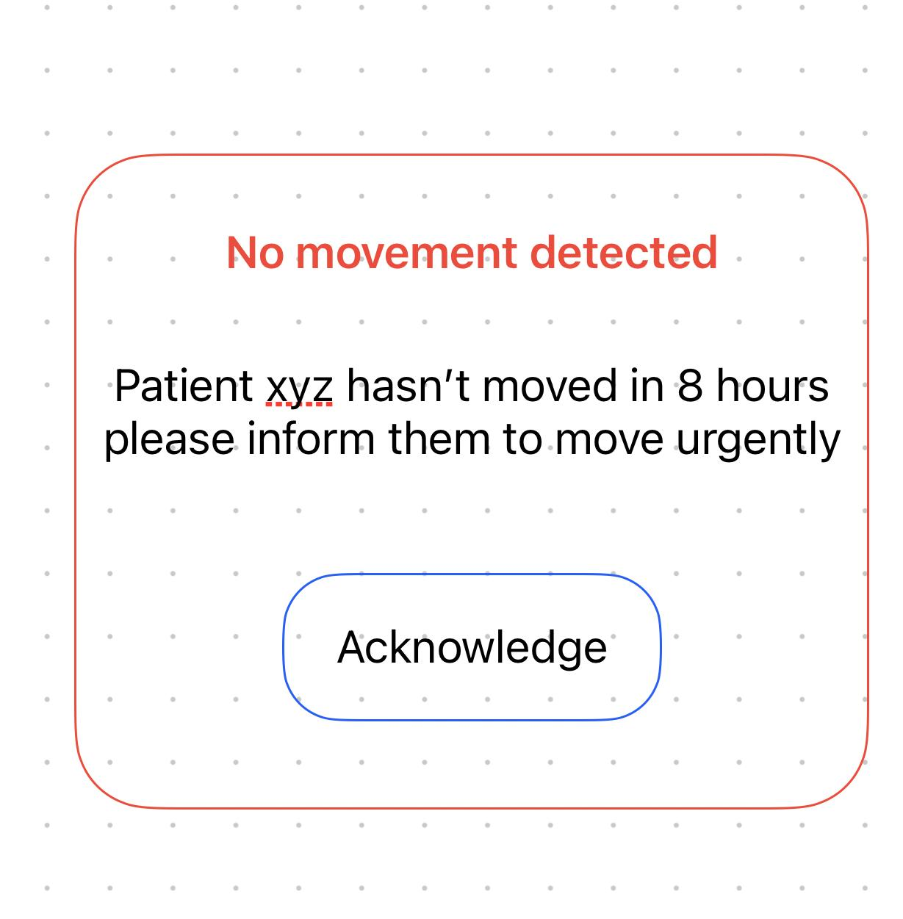
Actors:
Clinician, System
Goal:
To notify clinicians when a patient has not moved for 8+ hours.
Trigger:
System detects no significant movement from the patient for 8 hours.
Preconditions:
- Patient movement tracking is enabled
- Clinician account is active and linked to the patient
- Sensor data is continuously collected
Postconditions:
- Clinician is alerted
- Event is added to patient risk log
Main Flow:
- System collects movement data from patient sensors.
- System monitors movement over time.
- System identifies no movement for 8+ hours.
- System generates a no-movement alert.
- Alert sent to clinician dashboard.
- Clinician views the alert.
Alternative Flows:
A1: Clinician busy → Alert marked “unread” until accessed.
A2: Patient manually reports movement via app → System resets timer.
Exception Flows:
E1: Sensor malfunction → System generates “Movement sensor error.”
E2: Database timeout → System retries storing the alert.

3 Clinician: I want to be able to analyse low-movement areas View report showing regions with minimal pressure variation so I can better understand patient issues,
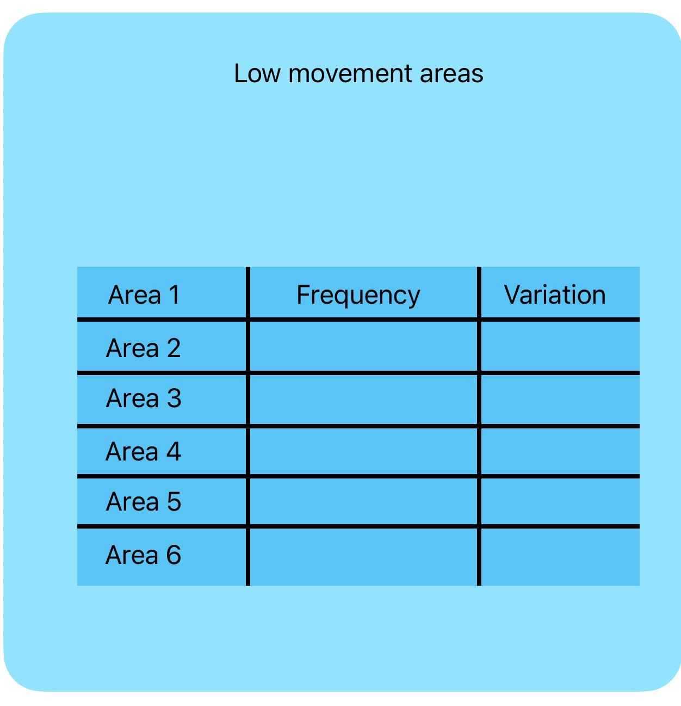
Actors:
Clinician, System
Goal:
To view patterns where the patient shows minimal pressure variation, helping clinicians detect issues early.
Trigger:
Clinician selects “Low Movement Analysis” from the dashboard.
Preconditions:
- System holds historical pressure/movement data
- Clinician account has access rights
- Patient has been monitored for at least 24 hours
Postconditions:
- Clinician receives analytical report
- System logs report access
Main Flow:
- Clinician navigates to the analysis section.
- Clinician selects a patient.
- System retrieves stored movement + pressure data.
- System identifies regions with minimum variance.
- System generates readable charts/tables.
- Clinician reviews the report.
Alternative Flows:
A1: No data available for selected period
→ System shows “Insufficient data.”
A2: Clinician selects custom filters (e.g., 12 hours, only back region)
→ System regenerates filtered report.
Exception Flows:
E1: Database connection error → “Unable to retrieve data.”
E2: Data corruption detected → System marks data as invalid.

4 Clinician: I want to see maps of regions which are frequently not moved often to better monitor and provide care
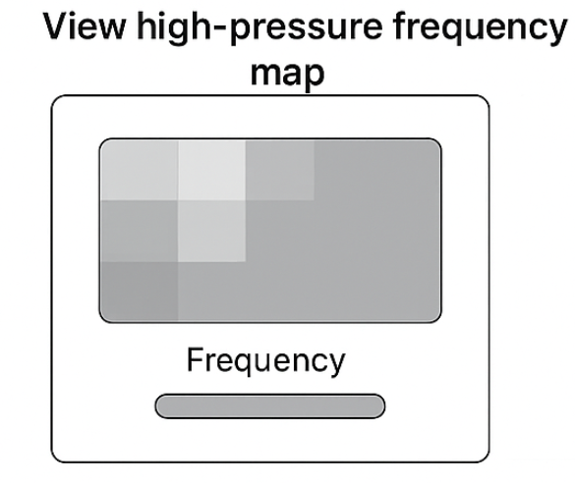
Use Case Title:
View Frequent Non-Movement Map
Actors:
Clinician, System
Goal:
To display a map showing areas the patient rarely moves, allowing improved care planning.
Trigger:
Clinician chooses “Movement Map” on dashboard.
Preconditions:
- Pressure/movement map data exists
- Sensors assigned to correct body regions
- Clinician account is authorised
Postconditions:
- Clinician sees colour-coded map
- System logs viewing activity
Main Flow:
- Clinician opens the movement map tool.
- System fetches relevant patient data.
- System calculates frequency of movement for each region.
- System renders map (heatmap or region map).
- Clinician examines high-risk zones.
Alternative Flows:
A1: Clinician changes date range
→ System updates the map.
A2: Clinician compares two patients
→ System displays dual-view mode.
Exception Flows:
E1: Missing region metadata → “Sensor region not mapped.”
E2: Data too sparse → “Unable to compute map.”

5 Admin: I want to manage users and permissions Add/remove users and control which clinicians/devices can access data
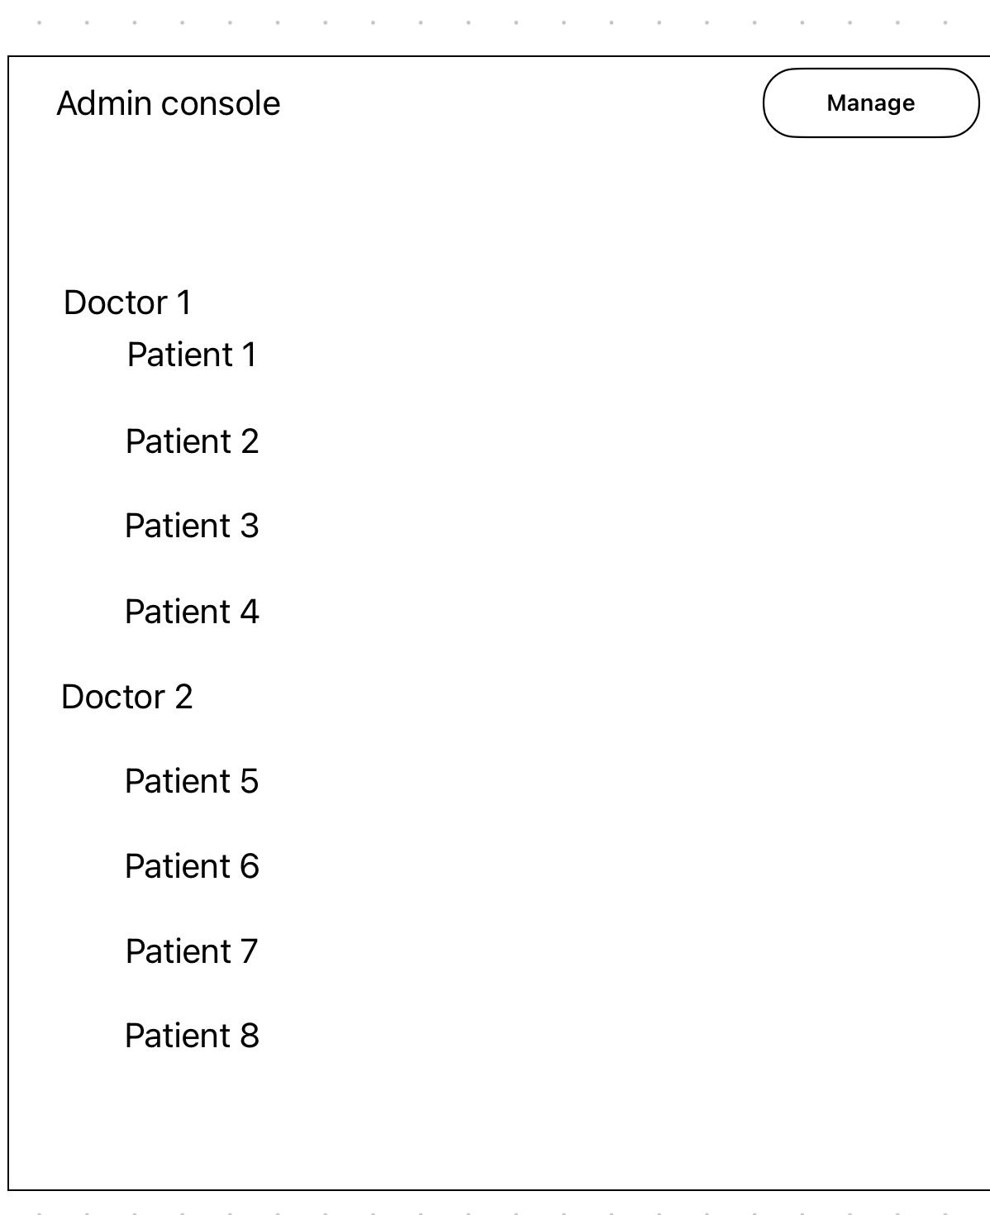

Use Case Title:
Manage User Accounts & Permissions
Actors:
Admin
Goal:
To add/remove users and control access privileges.
Trigger:
Admin opens the User Management panel.
Preconditions:
- Admin account authenticated
- System roles exist (Admin/Clinician/Patient)
Postconditions:
- User accounts updated
- Permissions saved to system configuration
Main Flow:
- Admin logs in.
- Admin navigates to User Management.
- Admin selects “Add User,” “Edit User,” or “Delete User.”
- Admin edits permissions (e.g., view patients, manage data).
- System stores changes.
- Confirmation message shown.
Alternative Flows:
A1: Admin assigns duplicate username → System shows validation error.
A2: Admin changes user role → System updates permissions automatically.
Exception Flows:
E1: Admin session expired → System forces re-login.
E2: Database write error → System rolls back changes.

6 Clinician: I want to respond to patient comments View and reply to feedback submitted by patients

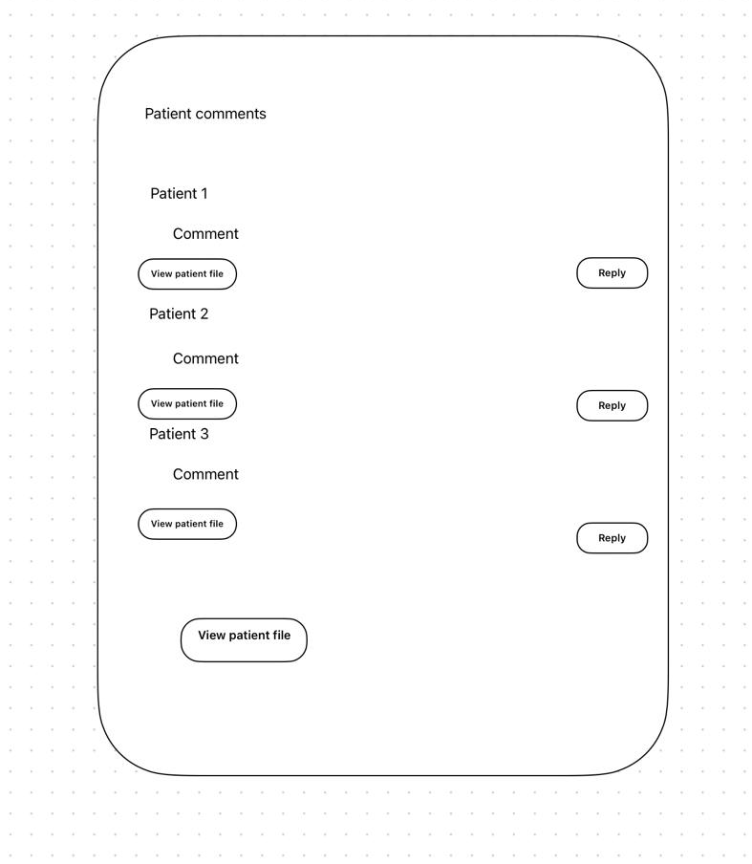
Actors:
Clinician, Patient, System
Goal:
To view and respond to comments or feedback submitted by patients.
Trigger:
Patient submits a comment OR clinician opens the feedback inbox.
Preconditions:
- Patient account exists
- Clinician linked to the patient
- Feedback module active
Postconditions:
- Response delivered to patient
- Interaction logged
Main Flow:
- Patient submits comment through app.
- System stores the comment in the database.
- Clinician opens feedback inbox.
- System displays list of patient comments.
- Clinician selects a comment and writes a response.
- System delivers message to patient.
Alternative Flows:
A1: Clinician marks comment as “resolved.”
A2: Patient edits or deletes their comment → System updates list.
Exception Flows:
E1: Message delivery failure → “Unable to send message.”
E2: Clinician attempts to access unassigned patient → Access denied

